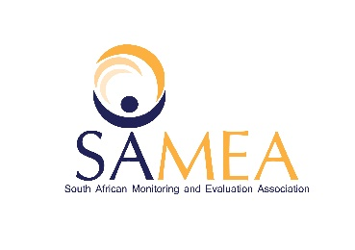

**Personal Details**

Name: Precious Isaac

Age: 28

Current employee (if employed): Department of Public Service and Administration

Experience in evaluation (years, months):

**Workshop Reflection**

Name of the workshop(s) attended: Building evaluation capacity in South Africa: gLOCAL concerns and effort; Public Sector Evaluation in South Africa: An influx; Evaluation that transforms; Panel discussion on evidence-based decision-making in the Western Cape, Challenges and changes since the start of the pandemic

Dates: 31 May 2021; 1 June 2021, 2 June 2021 & 4 June 2021

**Highlights** *(Please specify three highlights from attending the workshops):*

1. Highlight 1: Learning how M&E tools can be used to achieve transformation and innovation.
2. Highlight 2: Learning about the M&E framework being used in South Africa and that it is a growing area of specialization in South Africa
3. Highlight 3: Learning how professionals from different backgrounds are applying M&E tools and methodologies as part of their work.

**Lessons learnt** *(Please specify three things you have learnt from attending the workshops)***:**

1. Lesson Learnt 1: How M&E tools can be used continuously and utilised whilst the project is being implemented to give feedback in real time and indicate whether interventions are yielding expected results or note as was done in the Western Cape in response to the COVID-19 outbreak and subsequent lockdown.
2. Lesson Leant 2: The Do’s and Don’ts of setting up an evaluation process
3. Lesson Learnt 3: The findings of an evaluation process can lead to innovation and enhance sustainability. You get to identify what works so you can retain it and what hasn’t worked to understand it better so you can adjust accordingly in future.

**Challenges** *(Please specify any challenges you experienced while attending the workshops)***:**

1. Challenge 1: I missed day 1 of the Public Sector Evaluation in South Africa: An influx workshop because it was not specified that it would be presented over 2 days.
2. Challenge 2: I wish that there was a special session just for Emerging Evaluators. Just so we can engage and exchange insights.
3. Challenge 3: I really enjoyed gLOCAL week. It probably would have been better if it was done at a physical venue. I hope there will be more sessions throughout the year.

**Next steps** *(please specify three things you intend to do following participation in the workshops, this can be things you want to do differently, changes you want to implement, your personal plan of action):*

1. Next step 1: Research on M&E qualifications available in South Africa. Determine which qualification is best suited for me and whether I meet the criteria. Budget accordingly and apply for my studies.
2. Next step 2: Review my work projects to ensure that outcomes, indicators and targets etc. are clear and relevant and also aligned with strategic framework
3. Next step 3: Research to understand how monitoring and evaluation tools and approaches can be used to improve project implementation and/or service delivery