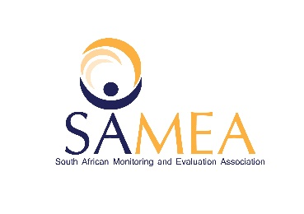

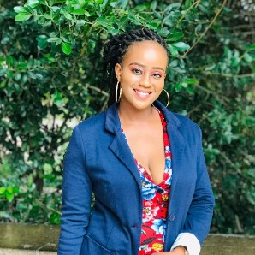

**Personal Details**

Name: Hlengiwe Abegail Qwabe

Age: 28

Current employee (if employed): Office of the Premier -Mpumalanga

Experience in evaluation (years, months): 2 years

**Workshop Reflection**

Name of the workshop(s) attended: Evaluation that transforms

Progress versus Outcomes – A non-linear approach to evaluation

Dates: 1-2 June 2021

**Highlights** *(Please specify three highlights from attending the workshops):*

1. Highlight 1 – my main highlight from the workshop is that in South Africa, transformation is dissected, we lack intergovernmental relations- which then causes resistance towards change and increases fear and resistance.
2. Highlight 2- Is that transformation is a gradual process, and has to be goal orientated. There needs to be a central point whereby consequence management can be introduced and where accountability can be enforced.
3. Highlight 3- we as public servants need to be open and transparent amongst ourselves, in such a way that information amongst ourselves should be shared easily to avoid doing things in silos and to avoid fruitless expenditure.

**Lessons learnt** *(Please specify three things you have learnt from attending the workshops)***:**

1. Lesson Learnt 1- the number one lesson that I let during the workshop is that we need to be very mindful of our environment, for if we are not cautious, our actions could have a negative impact on our future generation. We need to start introducing topics of sustainability and renewable energy in order to prepare ourselves for the unknown and make sure that we have acquired enough skill to deal with the upcoming uncertainties of this world.
2. Lesson Leant 2- through this workshop I have learnt that there is more than one way to address a certain problem than doing things the traditional way. I was introduced to a challenge map instead of a theory of change, it focuses on the wider problems that prevent a vision from being achieved.
3. Lesson Learnt 3- through every decision that involves the general public , it is unfair to only involve the donors/sponsors during the plenary phase , all relevant stakeholders need to be consulted and be brought on board , as these decisions affect them directly.

**Challenges** *(Please specify any challenges you experienced while attending the workshops)***:**

1. Challenge 1- my challenges were mostly network related, being kicked out of sessions by network due to load shedding and coming back to the session feeling lost and presentations carried on while I was waiting on the lobby.

**Next steps** *(please specify three things you intend to do following participation in the workshops, this can be things you want to do differently, changes you want to implement, your personal plan of action):*

1. Next step 1 – I would like to share with my colleagues the knowledge that I have gained from the workshop, by firstly encouraging them, that we don’t only focus on assumptions but by dwelling more on the problem areas that prevents us from achieving our vision ,then move into looking at the leverage points.
2. Next step 2 – to really thrive in my M&E career, being exposed to M&E professionals made me realise that this is an amazing field that requires determined and hardworking individuals that are always eager to learn.
3. Next step 3 – organize workshops that will focus on global warming and the impact it has on our future.